Electronics Product Reviews Analysis

Product Performance, Brand Benchmarking & Customer Sentiment Insights
Prepared by: [Your Name]
Role: Data Analyst
Tools Used: Excel · R · SQL (MySQL) · Tableau
Analysis Period: 2015 – 2018
Dataset Size: ~6,900 customer reviews

1. Executive Summary
This analysis evaluates customer review data for electronics products to understand product performance, customer satisfaction, brand positioning, and perception trends over time.
By combining ratings, recommendation behavior, sentiment analysis, and engagement metrics, the study provides a holistic view of how customers perceive electronics products and how brands—particularly Microsoft—compare against competitors.

Key Outcomes:
- Customer satisfaction across electronics products is consistently high
- Ratings, sentiment, and recommendation behavior are strongly aligned
- Microsoft performs competitively, but advocacy and sentiment consistency drive differentiation
- Sentiment trends offer early signals that ratings alone may miss

2. Business Objectives
The analysis was designed to answer the following business questions:
- Which products perform best in terms of customer satisfaction and engagement?
- How does Microsoft compare to other electronics brands?
- What factors drive high or low customer ratings?
- How does customer perception change over time?
- Are there cases where sentiment and ratings disagree—and what do they indicate?

3. Data Overview
- Unit of analysis: One customer review
- Final dataset: ~6,905 reviews
- Brands covered: 38
- Key variables analyzed:
  - Product ratings (1–5)
  - Recommendation behavior
  - Review sentiment
  - Review helpfulness
  - Review length
  - Time (year/month)
The dataset was cleaned, validated, and prepared to ensure accuracy, consistency, and reliability before analysis.

4. Methodology (High-Level)
The project followed a structured analytics workflow:
- Data Preparation
  - Removed non-informative fields
  - Handled missing values responsibly
  - Engineered features such as review length and time attributes
- Exploratory Analysis
  - Examined rating distributions, brand coverage, and recommendation patterns
  - Identified initial trends and biases
- SQL-Based Business Analysis
  - Computed product- and brand-level performance metrics
  - Analyzed sentiment and time-based trends
- Visualization & Storytelling
  - Built four interactive dashboards in Tableau
  - Focused on clarity, interpretability, and business relevance

5. Key Findings & Insights

5.1 Overall Customer Satisfaction (Dashboard 1 – Executive Overview)
- Customer ratings are heavily skewed toward 4–5 stars
- Over 90% of customers recommend the products they review
- Sentiment analysis confirms the positive bias observed in ratings
- Review activity varies over time, indicating periods of higher engagement
Insight:
The electronics market demonstrates strong customer satisfaction and advocacy, with sentiment reinforcing rating-based conclusions.
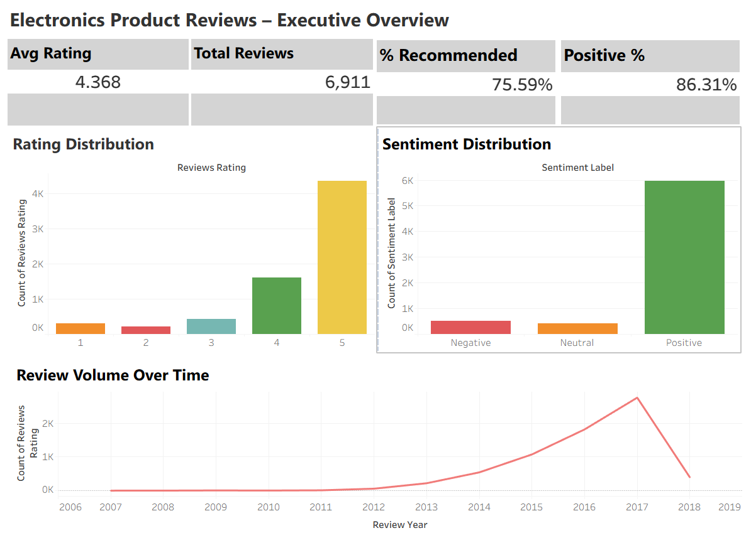

5.2 Product Performance Insights (Dashboard 2)
- High ratings do not always correspond to high review volume
- Some niche products receive excellent ratings but limited attention
- Recommendation rates vary even among similarly rated products
- Review length alone does not guarantee usefulness; concise reviews can be more impactful
Insight:
Product success is multi-dimensional—quality, popularity, and usefulness must be evaluated together.
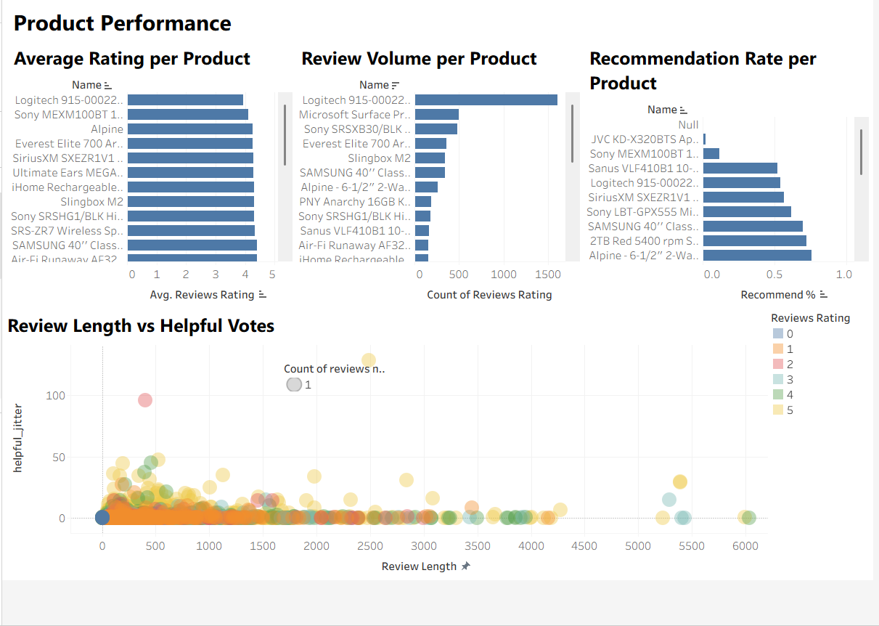

5.3 Brand Comparison: Microsoft vs Competitors (Dashboard 3)
- Microsoft products maintain competitive average ratings
- Recommendation behaviour differs more significantly than ratings
- Sentiment distribution highlights perception differences across brands
- A small number of brands dominate customer engagement and visibility
Insight:
While Microsoft performs well on satisfaction metrics, sustained differentiation depends on customer advocacy and sentiment consistency.
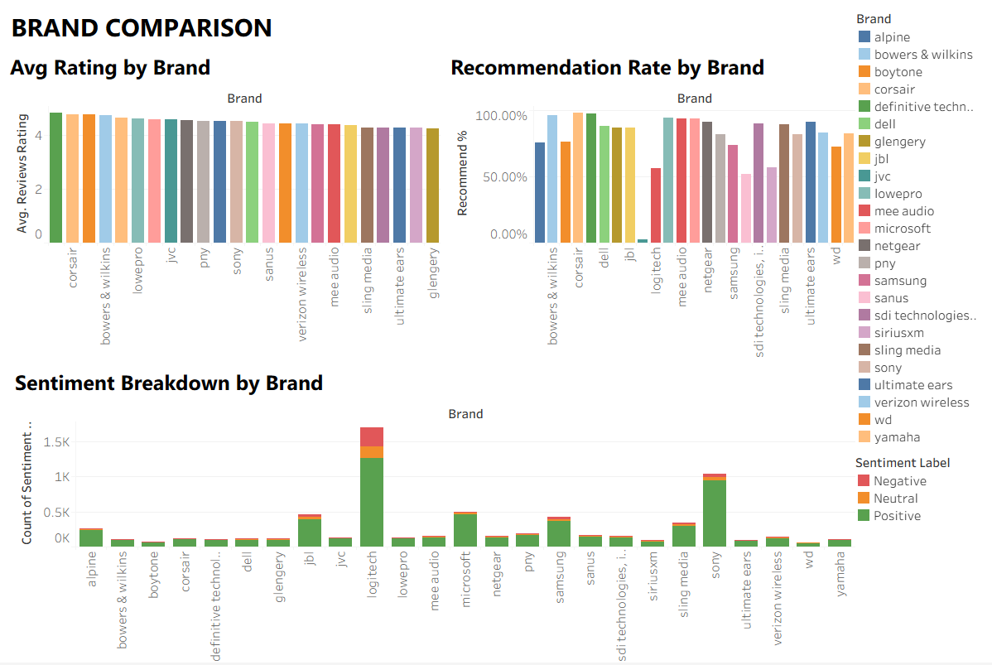

5.4 Sentiment & Time-Based Trends (Dashboard 4)
- Average ratings remain stable over time
- Increases in negative or neutral sentiment often precede minor rating declines
- Sentiment and ratings usually align, validating the analysis
- Contradictory cases (high rating + negative sentiment) reveal nuanced customer experiences
Insight:
Sentiment analysis provides early warnings and contextual depth beyond star ratings alone.
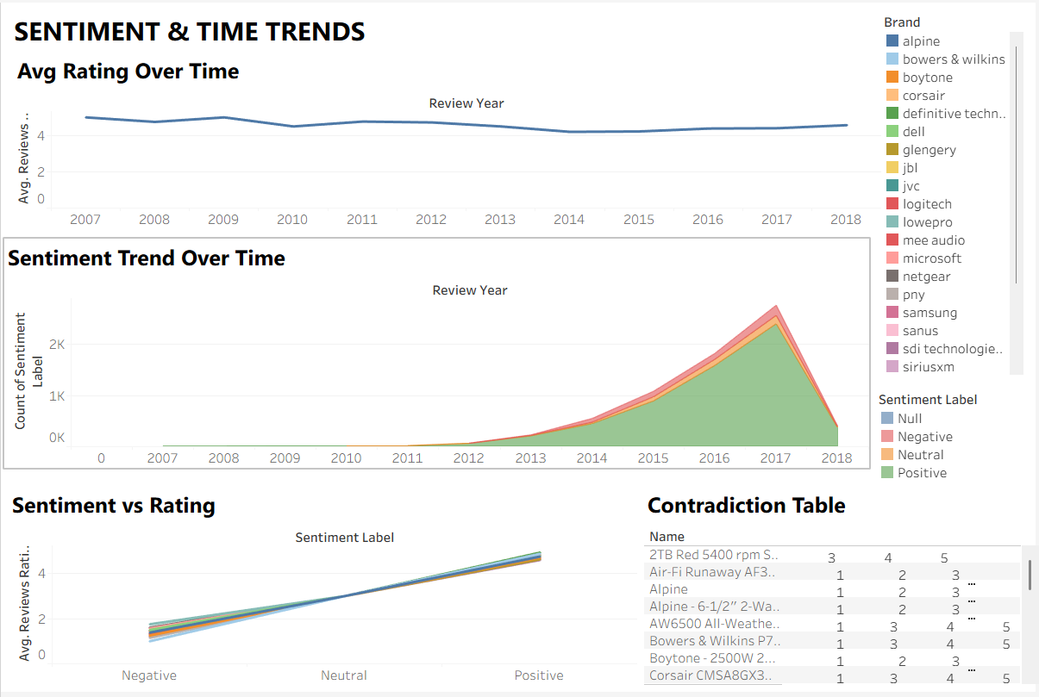

6. Strategic Implications
Based on the analysis:
- Ratings alone are insufficient for decision-making
- Recommendation behavior is a strong indicator of true satisfaction
- Sentiment trends should be monitored as an early risk signal
- Brands should focus on consistency in customer experience, not just average scores
- High-impact reviews matter more than review volume alone

7. Limitations & Notes
- Sentiment labels are pre-generated and may not capture sarcasm or mixed tone
- Review data is limited to available platforms and time range
- Results should be interpreted alongside other business metrics (sales, returns, support tickets)

8. Conclusion
This analysis demonstrates how customer review data can be transformed into actionable business intelligence. By integrating quantitative ratings with qualitative sentiment and behavioural indicators, the project provides a nuanced and reliable understanding of product and brand performance in the electronics market.
The approach is scalable, repeatable, and suitable for ongoing monitoring of customer perception.

